CLOUD COMPUTING LAB

**Name: Nayab Khazin Reg No: 2023-BSE-046**

**Submitted to: Sir Muhammad Shoaib Class: 5B**

**LAB #09**

**Task 1 — GitHub CLI, Codespace setup and authentication**

task1_gh_install.png

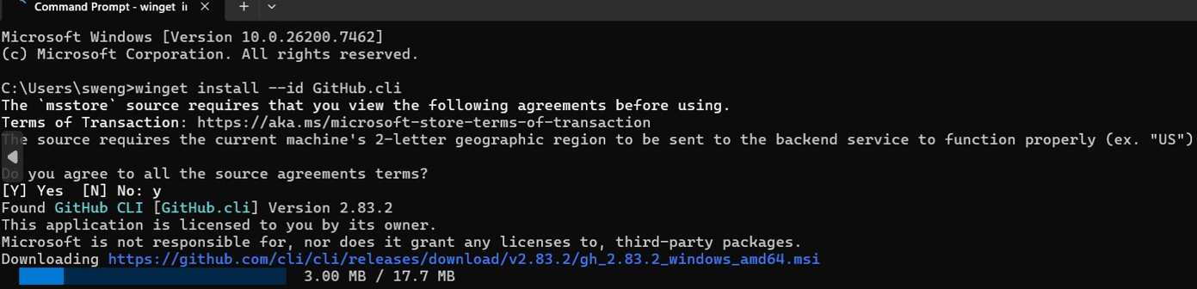

task1_gh_auth_login.png

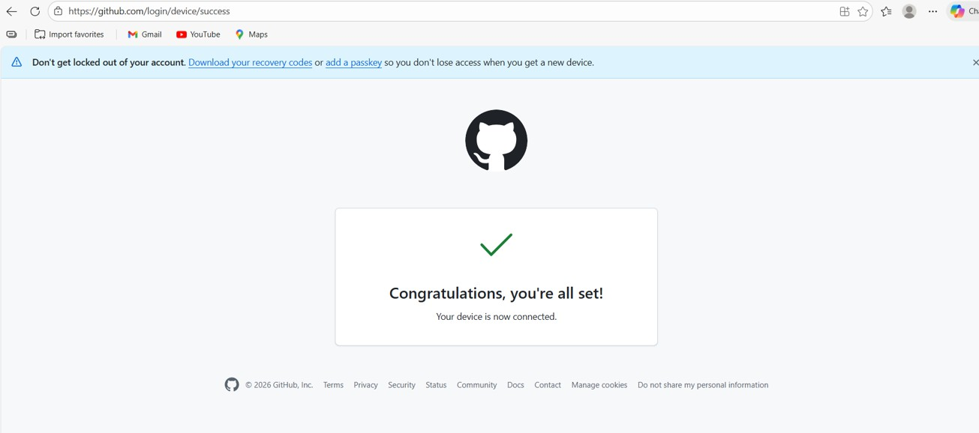

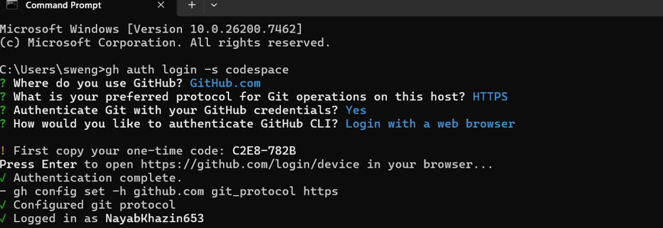

task1_codespace_list.png

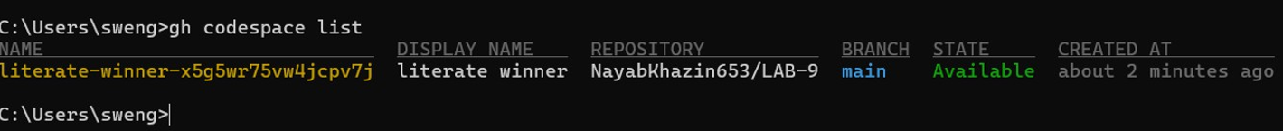

task1_codespace_ssh_connected.png

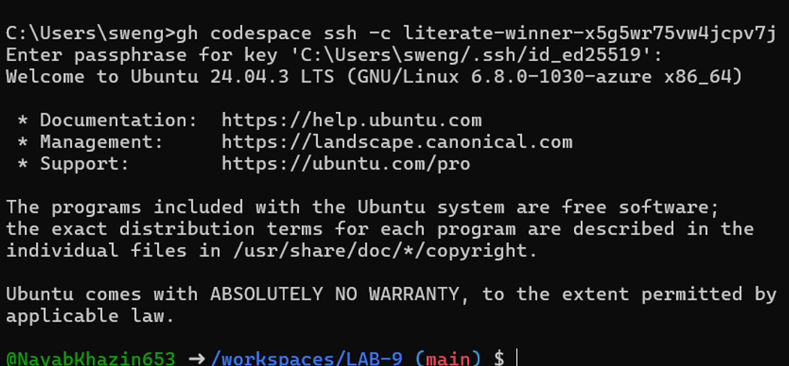

**Task 2 — Install AWS CLI inside the Codespace and configure it**

task2_aws_install.png

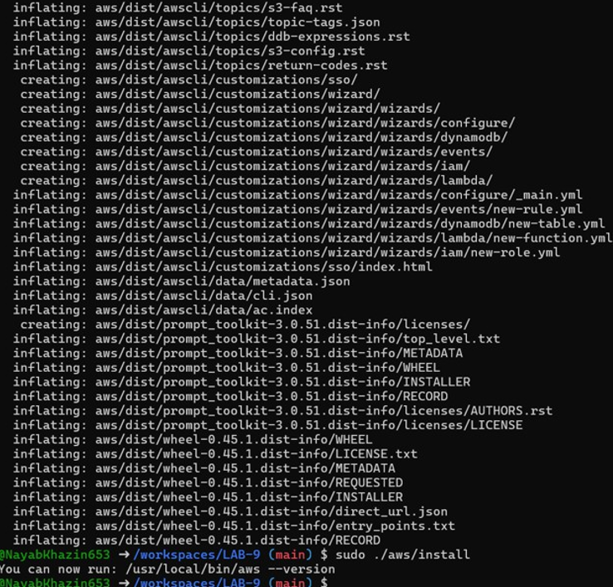

task2_aws_install_and_version.png



task2_aws_configure_and_files.png

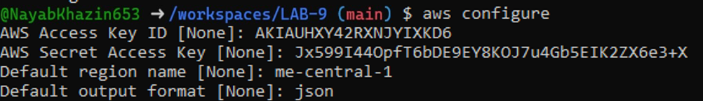

task2_aws_get_caller_identity.png

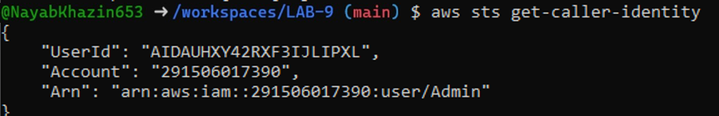

Task 3 — Create security group and add ingress rules using Codespace IP:

task3_create_security_group_output.png

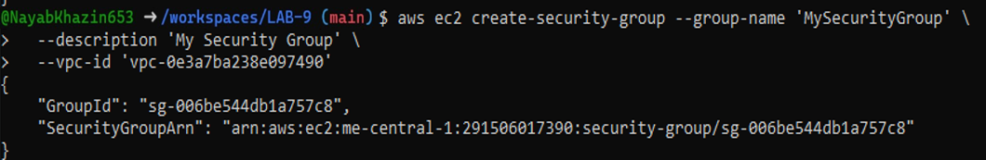

task3_describe_sg_before_ingress.png

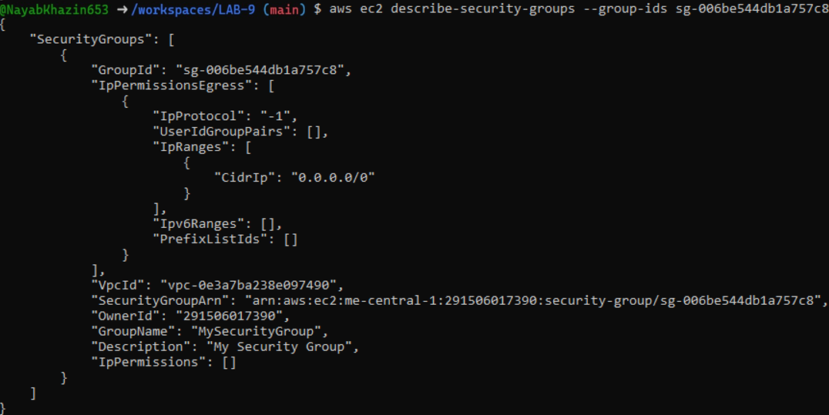

task3_codespace_public_ip.png



task3_authorize_ssh.png

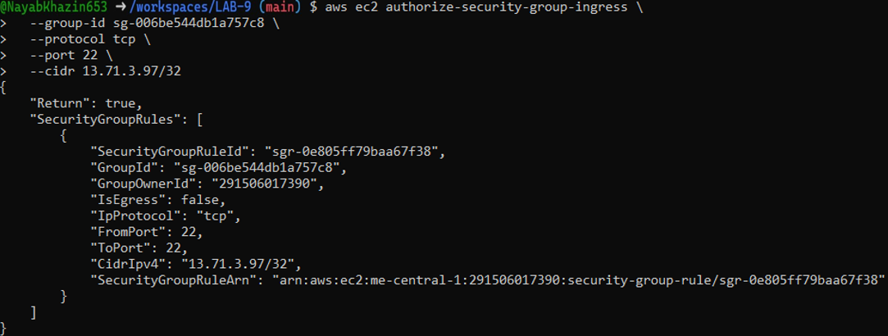

task3 _describe.png

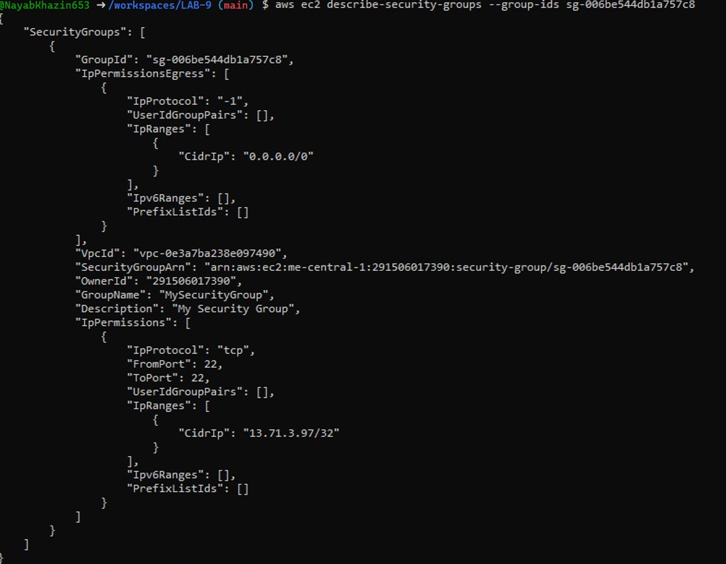

task3_authorize_http_and_describe.png

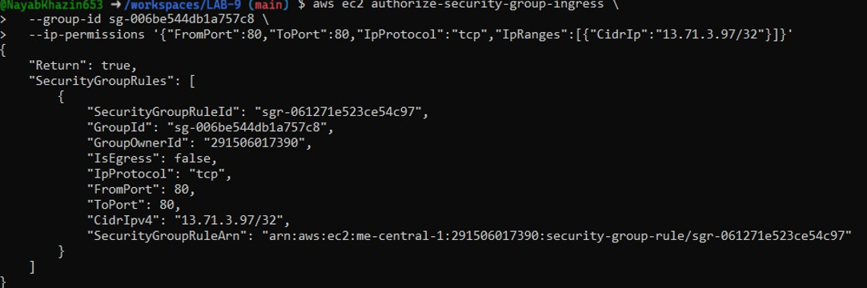

task3_describe_sg_final.png

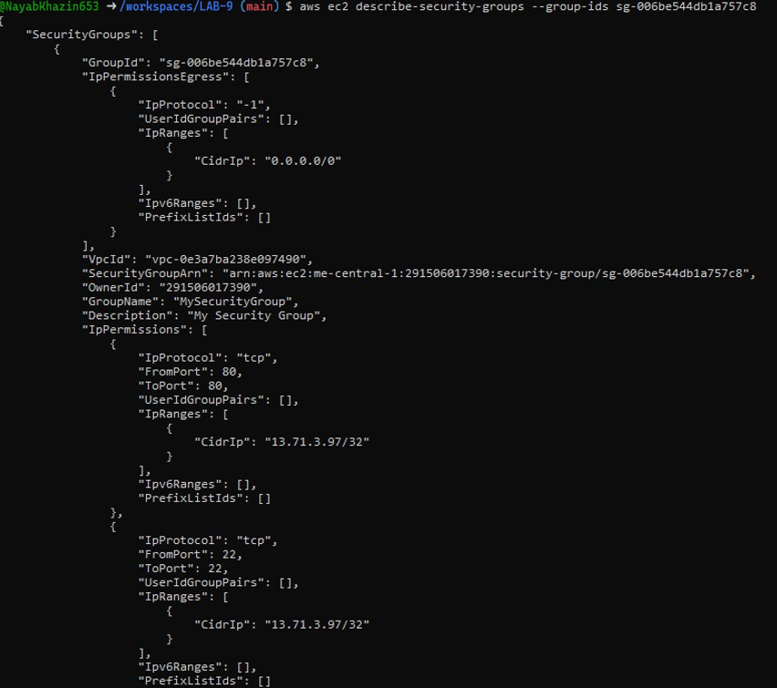

**Task 4 — Create a key pair, describe key pairs, and launch EC2 instance**

task4_create_keypair_output.png

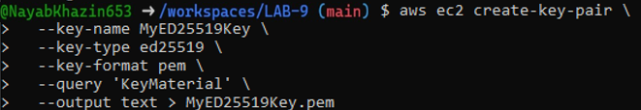

task4_describe_keypairs.png

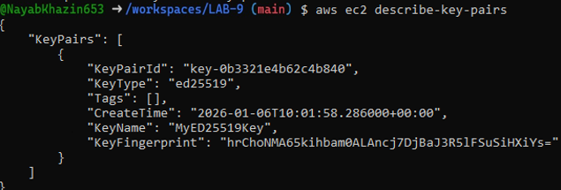

task4_run_instances_output.png

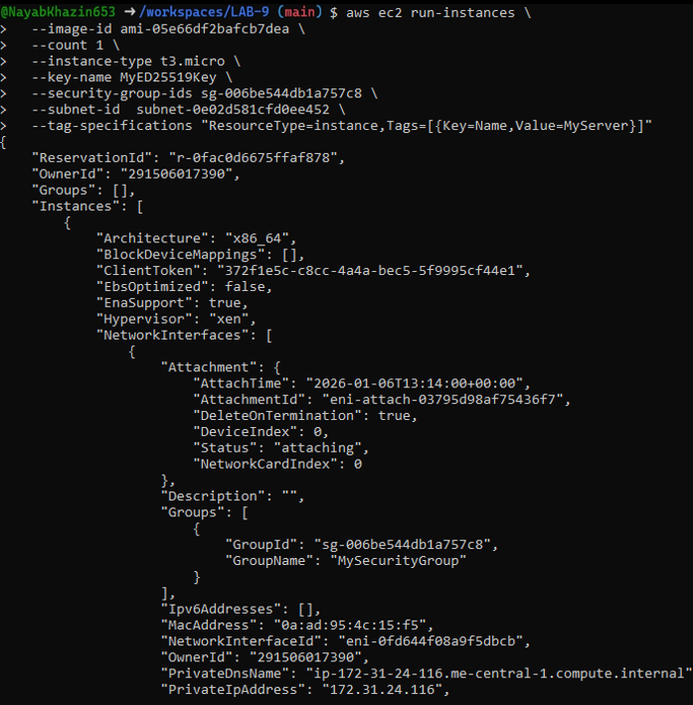

task4_describe_instances_public_ip.pn

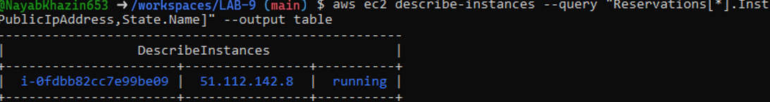

Task 5 — Understand AWS describe-* commands

task5_describe_security_groups.png

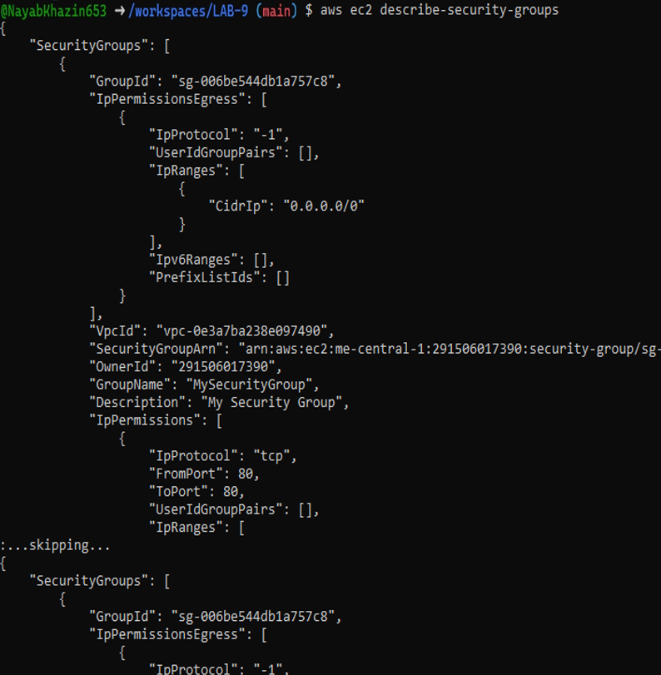

task5_describe_vpcs.png

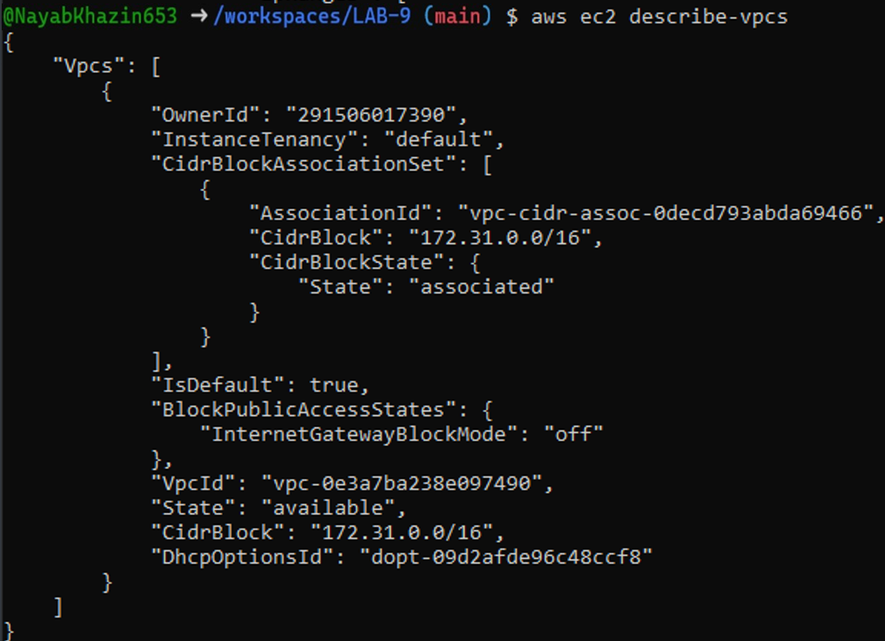

task5_describe_subnets.png

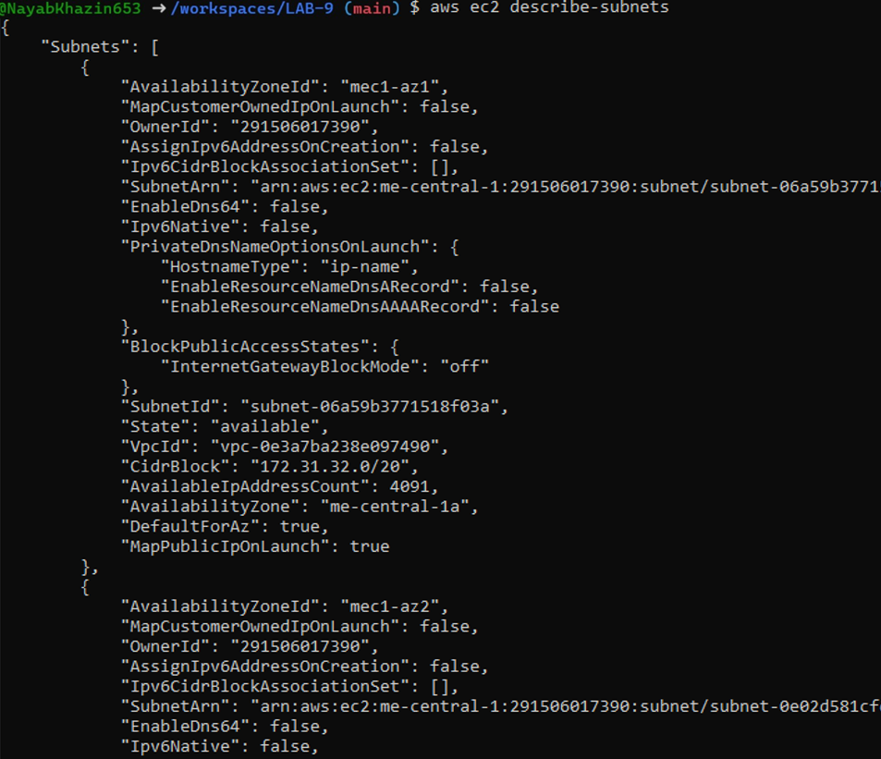

task5_describe_instances.png

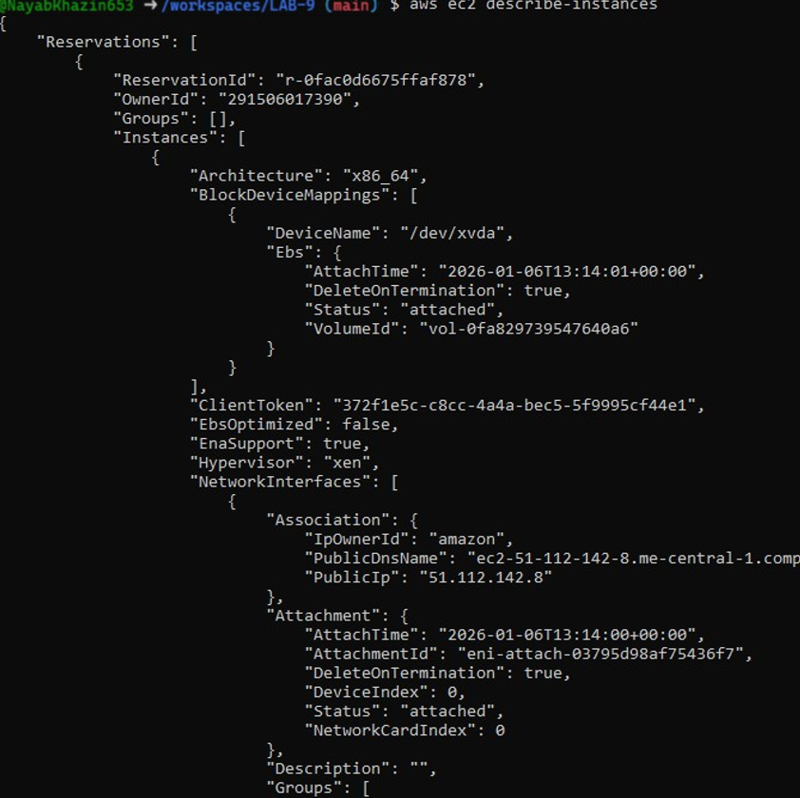

task5_describe_regions.png

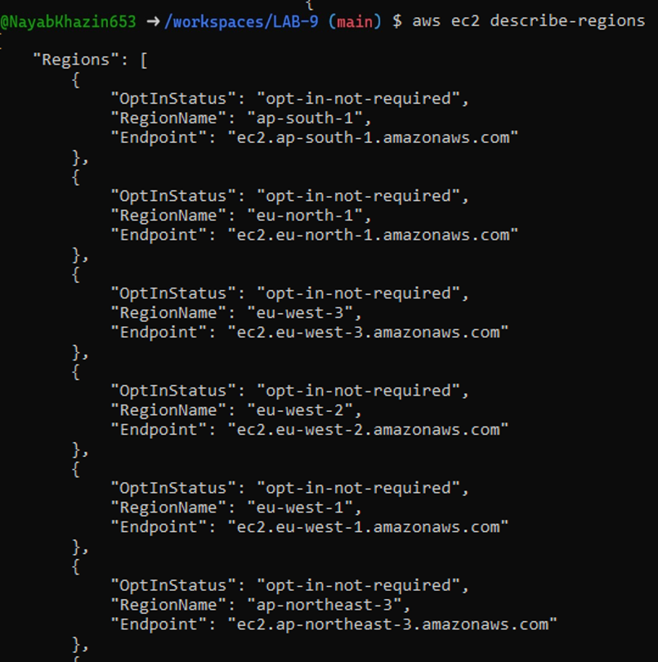

task5_describe_availability_zones.png

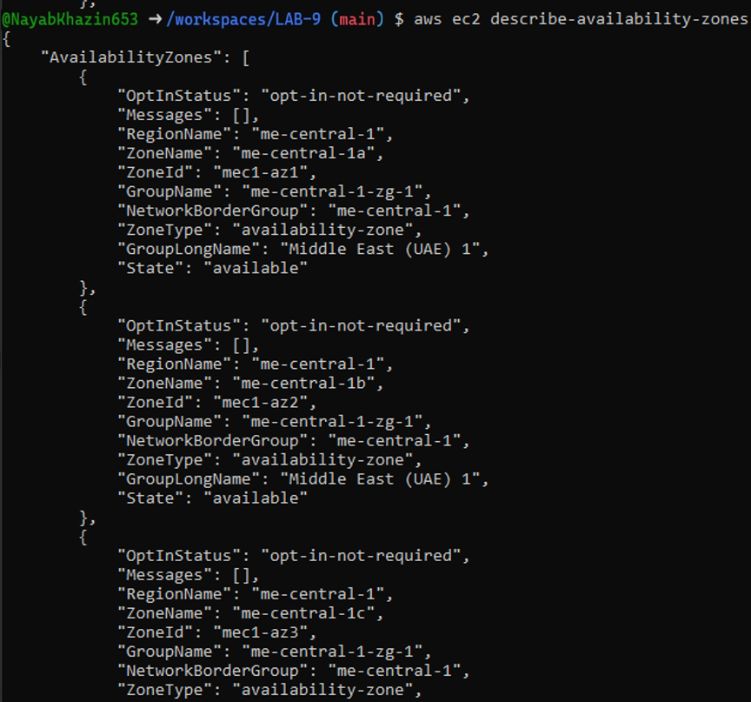

task6_create_group_and_user.png

**Task 6 — IAM: create group, user, attach policies, create console login & keys**

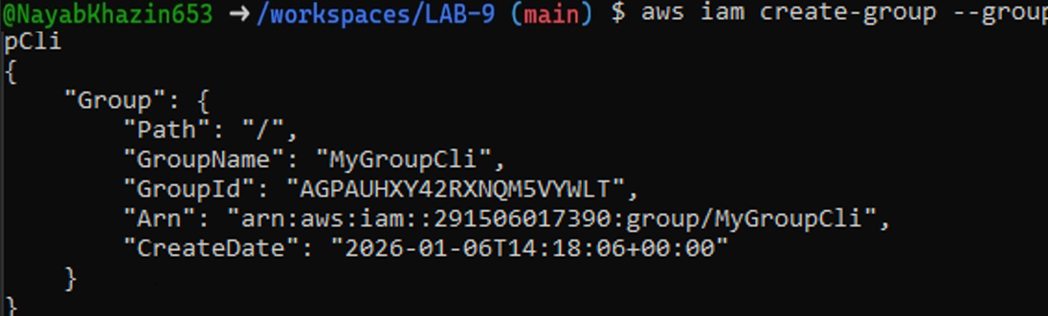

task6_create_group_and_user.png

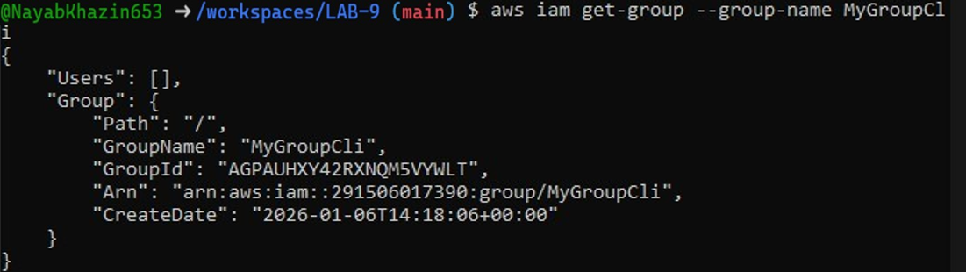

task6_create_group_and_user.png

task6_create_group_and_user.png

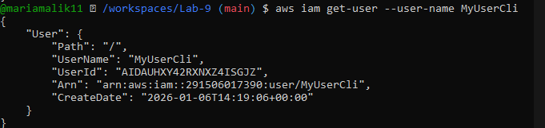

task6_add_user_to_group_and_verify.png



task6_add_user_to_group_and_verify.png

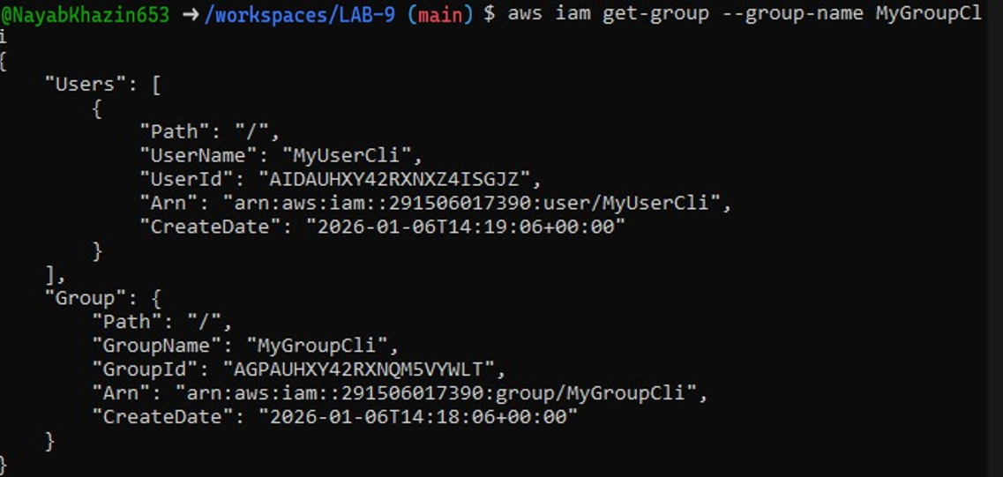

task6_policy_list_and_attach.png

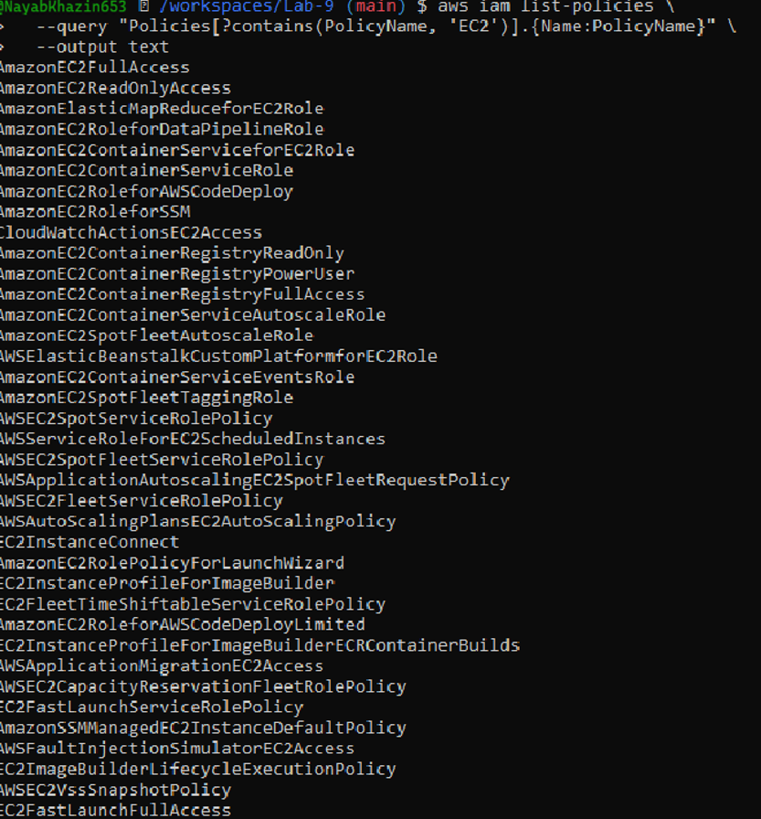

task6_policy_list_and_attach.png

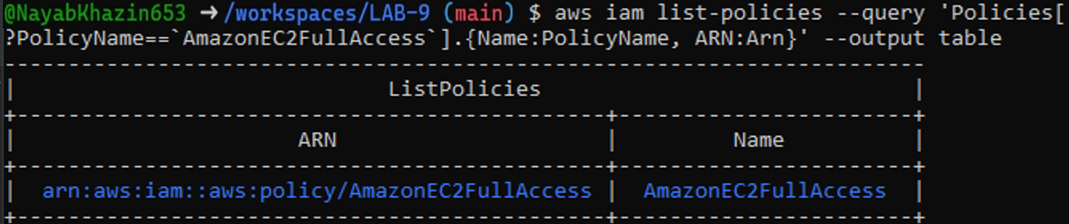

task6_policy_list_and_attach.png



task6_policy_list_and_attach.png

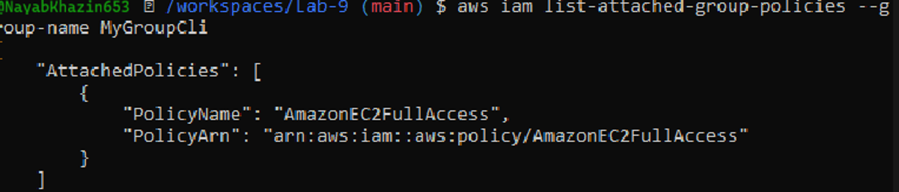

task6_create_login_profile_and_signin.png



task6_create_access_key_output.png

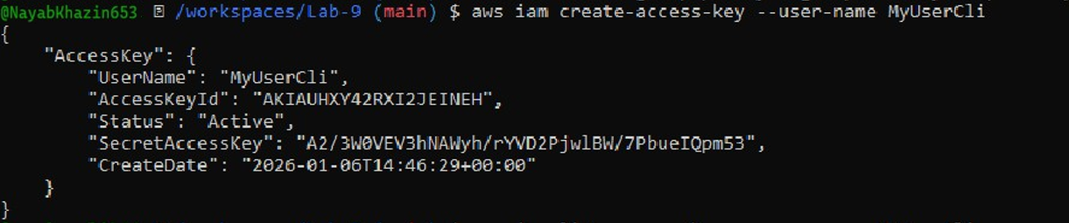

task6_create_access_key_output.pn

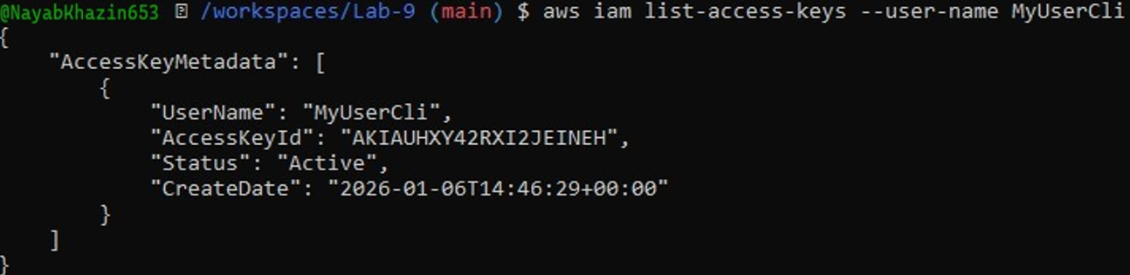

task6_create_access_key_output.png

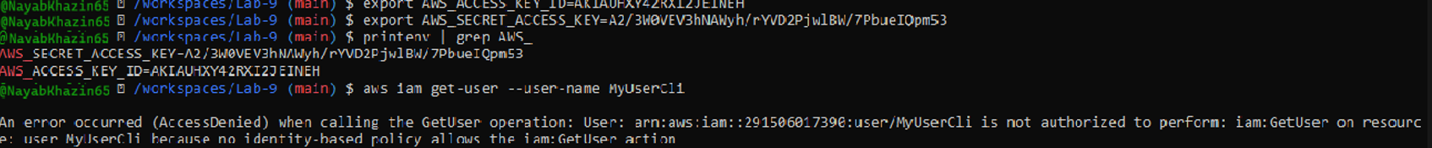

task6_env_exports_and_get_user_error.png

**Task 7 — Filters: query with filters to find instances and their attributes**

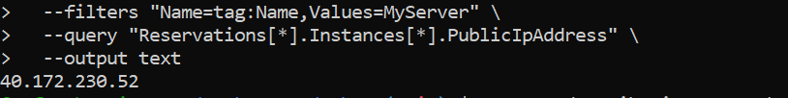

task7_filter_by_instance_type.png

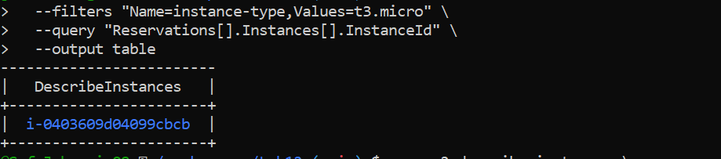

task7_filter_by_subnet.png

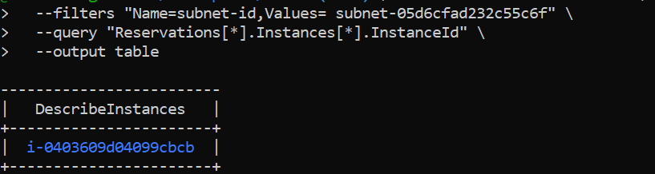

task7_filter_by_vpc.png

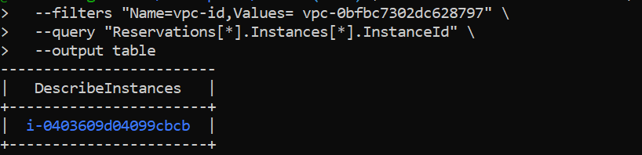

**Task 8 — Use --query to format outputs for reporting**

task8_query_table_instances_name_ip.png

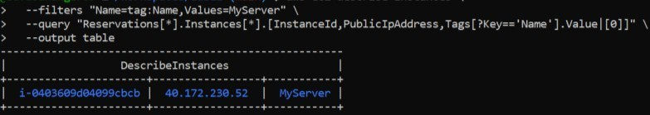

task8_query_table_instance_state.png

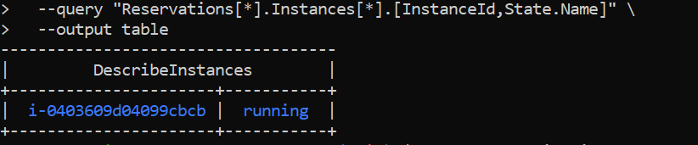

task8_query_table_instance_type_az.png

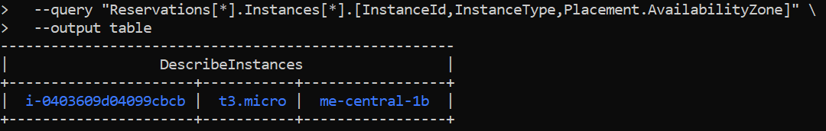

**Cleanup — Remove resources to avoid charges**

cleanup_terminate_instance.png

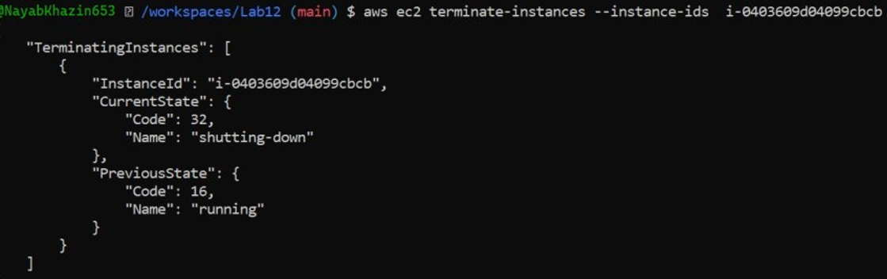

cleanup_delete_volumes_snapshots.png

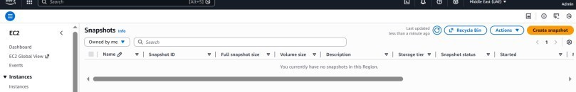

cleanup_delete_security_group_and_keypair.png

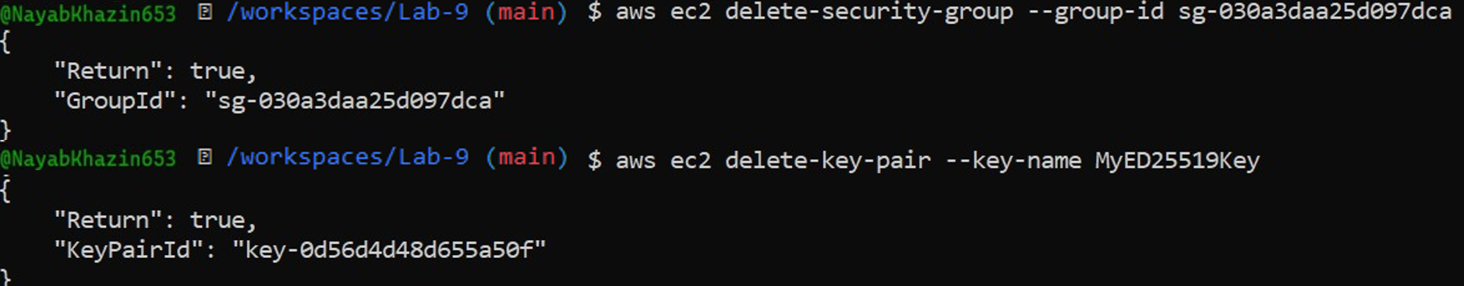

cleanup_iam_users_deleted.png



cleanup_summary.png

